12/10/2020

Student Name: Tai Anh Nguyen

Student ID & Oracle ID: 13154113

Tutor: Steven Jie hua

Data Visualisation and Visual Analytics - 32146

Design: Data Visualization

1. Select a graph visualization metaphor that you believe is most appropriate to be used to represent the flights routes. Providing support statement (or arguments) to convince others about your selection. (4%)

Tableau provides variety of maps for visualizing the geographic and spatial data such as Proportional symbol maps, Choropleth maps (filled maps), Point Distribution Maps, Heatmaps (density maps), Flow maps (path maps), Spider maps (origin-destination maps) that can be represented on the maps to recognize patterns and trends around the geographic areas and make our visualizations interesting. Each map has its own features hence it can be used to visualize an appropriate dataset.

Spider Graphs represent the route on the geographical world map and shows the route/path between the source and the destination points. Such Maps can be created in number of ways. The method that was followed in this report was to use two functions as a new version of tableau released just recently. The entire process has been discussed in the section below.

1. Describe the high-level model (or framework) of the visualization to be designed. The model will show the main characteristics of the visual data processing. a. Briefly describe the cycle of visual data processing with your proposed model. (4%)

First step we need to understand our data, the given csv file is loaded into the Microsoft Excel where the entire data is processed and transformed as per the requirement.

Tableau is adding two spatial functions that will make analysing location data easier than ever. The spatial functions are called MakePoint and MakeLine. These functions required latitude and longitude values on each data points.

As the raw given dataset do not have Latitude and Longitude of each city. Therefore, utilising Tableau features by it automatically generated the Latitude and Longitude. Then export all the details into new csv file called Geographic Location.

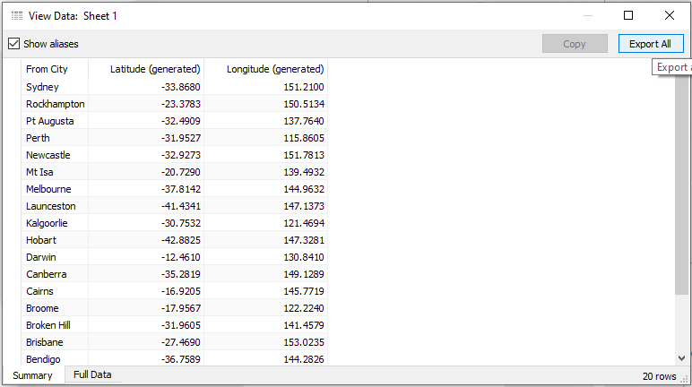

*Fig.1. Geographic Location extracted from Tableau*

Next step, the Flight data.csv and Geographic Location.csv file was loaded in the Tableau using data sources. Further both the files were joined using a full outer join to generate latitudes and longitudes each origin and destination of every specific routes. Based on the given data set and 3 attributes “From_City, Latitude, Longitude” were extracted in Geographic Location.csv file, some new attributes were generated for later use such as From_Latitude, From_Longitude, To_Latitude and To_Longitude.

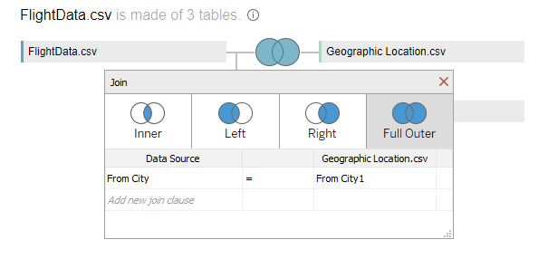

*Fig.2. From City latitudes and longitudes*

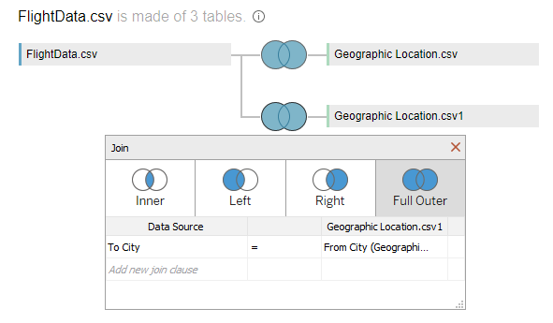

*Fig.3. To City latitudes and longitudes*

Using MakePoint function can turn non-spatial data sources like Excel tables into spatial data sources. In other words, using latitude and longitude fields in a spatial join to join datasets based on their spatial relationship.

Using MakeLine function makes connecting between two points on a map simple because only need the latitude and longitude for the origins and destinations flight data. This function generates geodesic lines, which will display as curved when connecting locations are far on the earth.

Then create the calculated field with one line of code by merging two functions and finally a Routes attribute was generated which showed how our flight routes was connected. Spatial calculations make geospatial analysis simple and reveal another capability in Tableau.

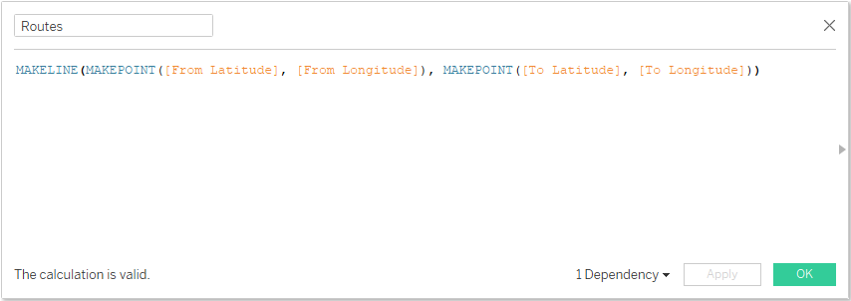

*Fig.4. Coding line*

1. Specification of the design of visualization. Describe the layout technique to be used for graph drawing. (2%)
2. Layout design specification, including (but not limited) the following details:
3. How to deal with the edge-crossing problem, (2%)
4. How to deal with the object node-overlap problem, (2%)
5. How to enhance the readability of the layout, (2%)
6. Labelling techniques. (1%)

Each city is represented using customised icons and a trajectory in form of curved arch is shown connecting both the cities .To Increase the readability and interaction with graph tools like tooltips, labels, colours have been used which are discussed in this section, the visualization’s layout and steps is performed to achieve the graph denoted in detail.

Moving to the worksheet the first step is to enter manually latitudes and longitudes (map coordinates) into workflow since all generated latitudes and longitudes have been changed to four fields From_Latitude, From_Longitude, To_Latitude and To_Longitude.

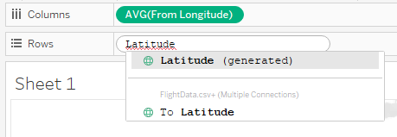

*Fig.5. Manually enter map coordinates*

Then drag From_City attribute into the detail box and it automatically plots a node for each distinct city on a map. In our data set only one distinct node corresponding to each city is generated so that the problem of node overlapping is not faced.

Further the Routes field is created by coding which when dragged into the detail box and it generates a map consisting of all the line routes from origins to destination cities.

Finally, both these graphs are merged by dual axis option to represent both the nodes and edges and show the overall context of information on the map. It is shown in figures below.

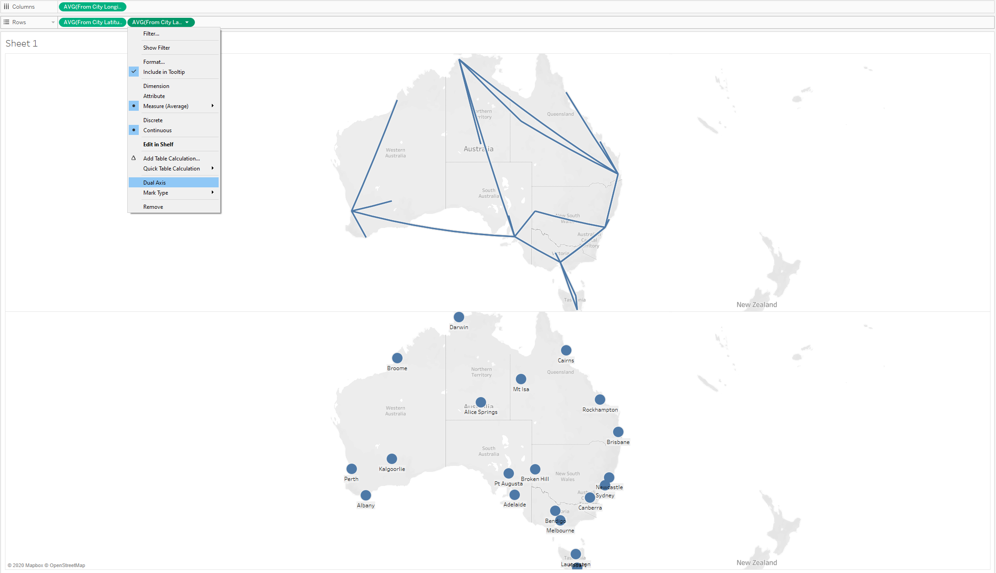

*Fig.6. Merging both graphs by dual axis*

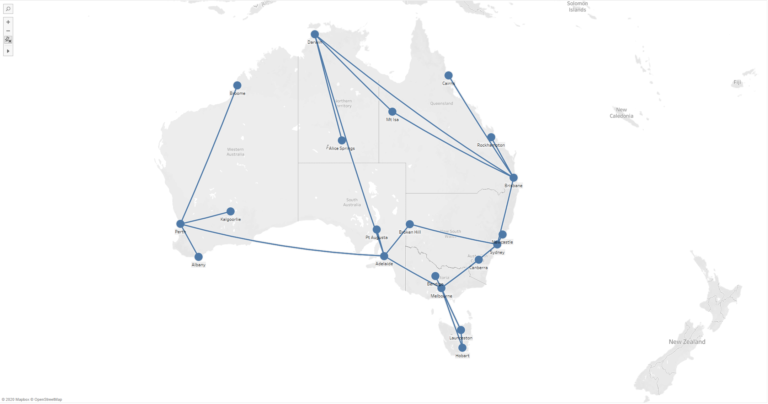*Fig.7. Graph depicts overall context*

The From_City attribute was dragged into label box to add labels for all the cities in the graph. The Price was dragged into colour box to classify the cheap and expensive flights based on the change of colour and shape. The size of the plane icon also was changed based on the frequency of the flights at each city by placing From_City attribute into size box. The Engine Model and AirSpace Class attributes were dragged into detail to show the detail in each flight when click on the datapoint.

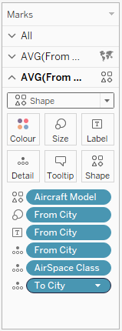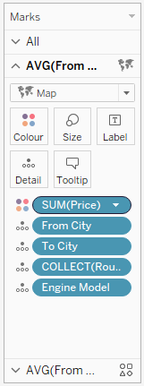  
*Fig.8. Features in Tableau*

Finally, changing the Background Maps to Satellite option to increase readability. Tableau provides a lot of great features to enhance the readability and usability of graph visualization through size, details and labels shown in the figures below.

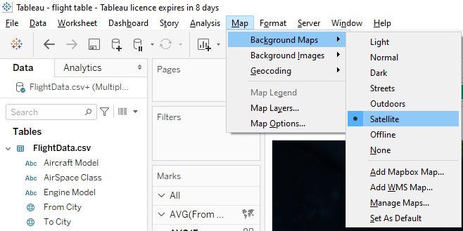  
*Fig.9. Changing Background Maps*

1. Specification of the design of Pictograms (Icons) & Graphics, including (but not limited) the following details
2. Pictogram (Icon) design, (4%)
3. Graphic attributes design, (2%)
4. How to map domain-specific attributes to graphic attributes (2%),
5. How to address the data scale problem, particularly in dealing with the computational cost for running a selected layout algorithm (2%)
6. How to enhance the readability of domain-specific attributes (1%)

For further qualities and requirements of the graph, each flight from origin and destination city has been represent using customised aircraft icons

After designing the symbol for each category, the customised icon was added to the shapes repository and then assigned by dragging Aircraft Model into shape box and choosing appropriate palette then apply it.

Each destination node has been represented by the shape of different planes. The use of such graphics for domain specific attributes can not only increase the usability but also depicts the overall delivery of the information that our graph wants to show the users.

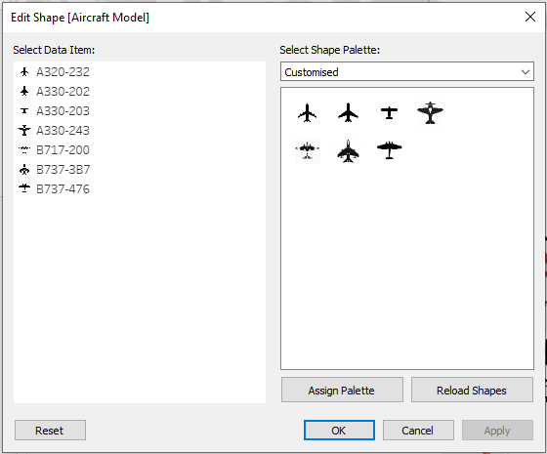

*Fig.10. Set up Aircraft icons*

For the scalability, the design and visualization above can effectively to represent our dataset. In the case data and records of the edges become bigger it will definitely take high computation resources to build the same for huge dataset. However, in order to address the data scale problem in large dataset, one approach can be used. It is only highlighting one specific flight and update all needed information related to it. Then it will easily reduce the computational cost for running algorithm.

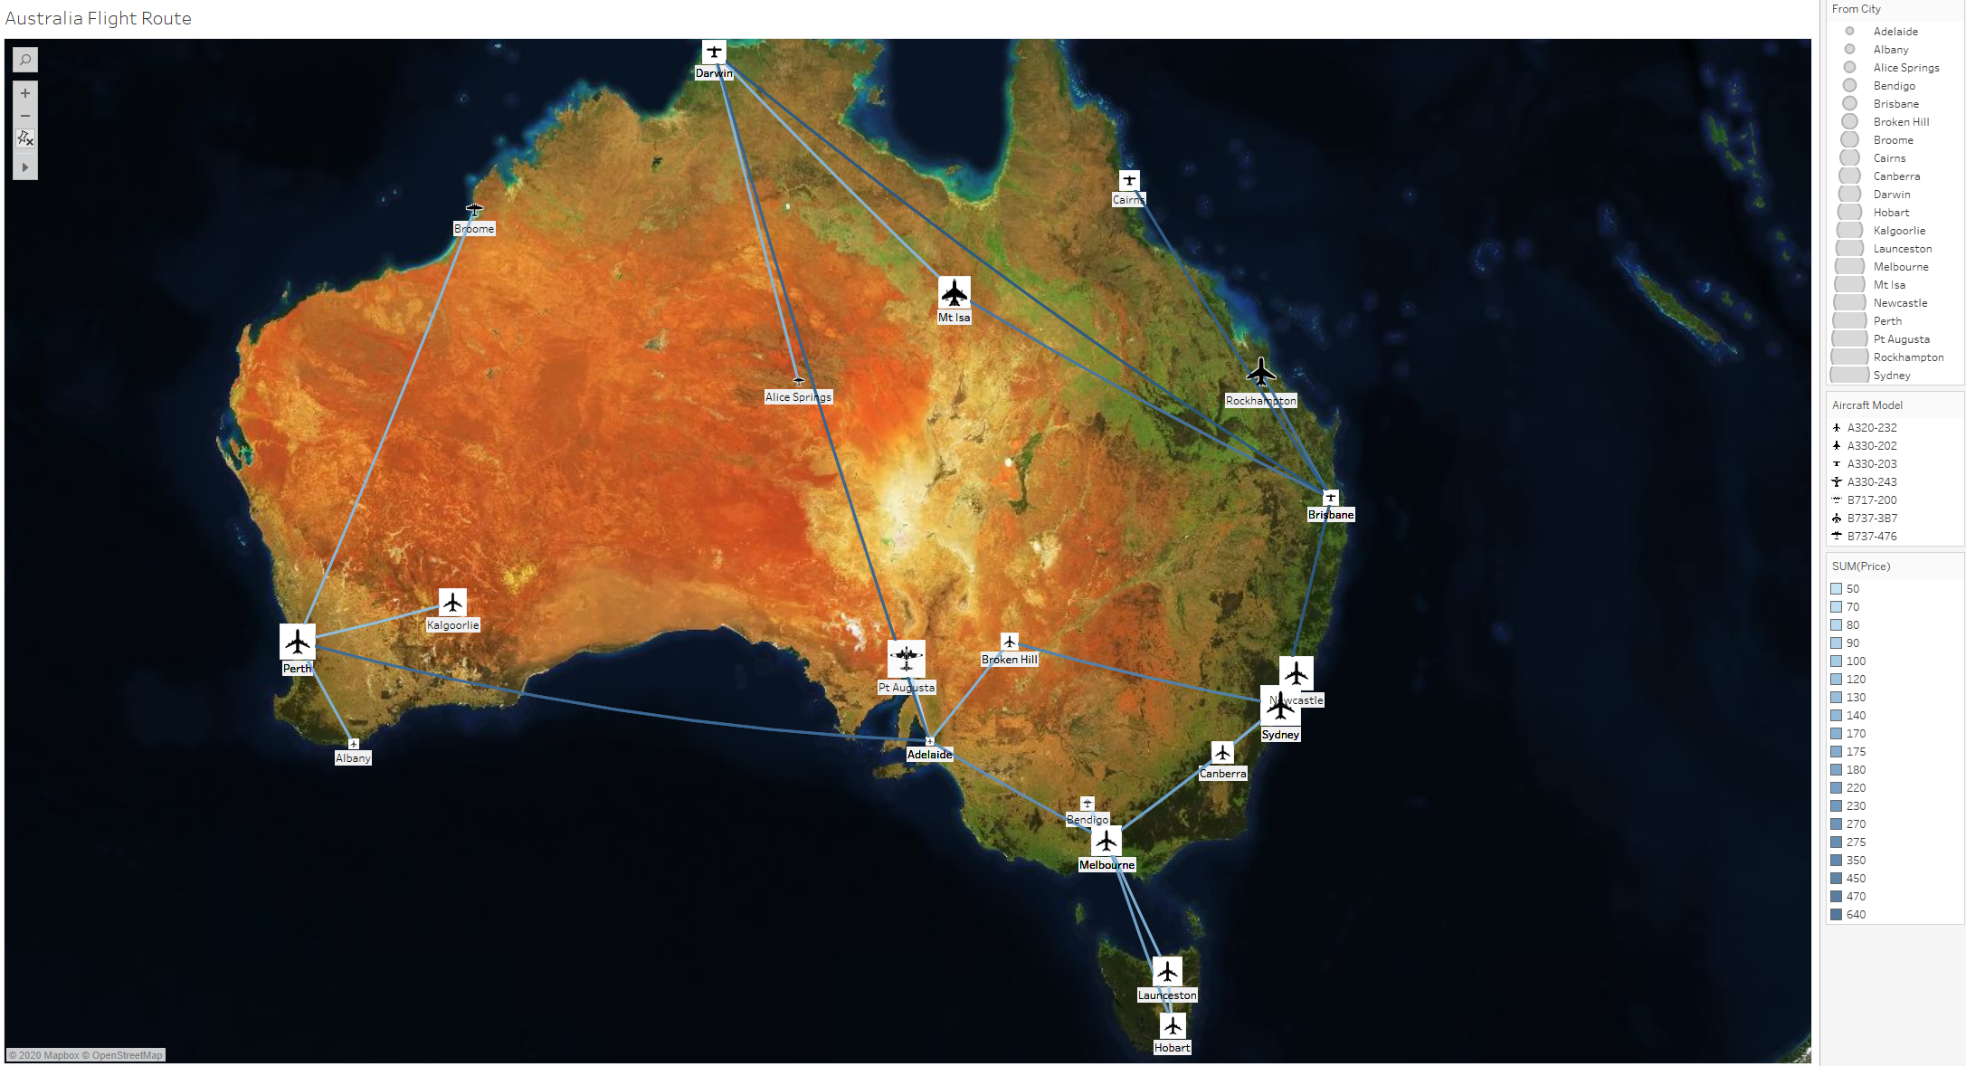

*Fig.11. Final Graph*

From the final layouts, the readability of graph with specific attributes such as Aircraft Model, Price and Cities has been improved by using different colours and customised icon.

1. Specification of the design of an associated navigation scheme that includes the viewing scheme and interaction scheme. (3%)
2. View Transformations specification, including (but not limited) the following details:
3. In-between views design, algorithm and transformation algorithm, (3%)
4. Human cognition process consideration during view transformations. (3%)
5. HCI evaluation design specification, including (but not limited) the following details:
6. Evaluate the efficiency of selected navigation mechanism by using Fitts's law and a usability study. (3%)

There are many navigation techniques can be used for user to analyze that data. Since our data set is small, Zoom and Pan algorithm is suitable to perform. The entire process is shown below.

Some users want to search the route from Melbourne to Newcastle. At first glance, people will think they need to transfer their flight at Canberra (Figure 12)

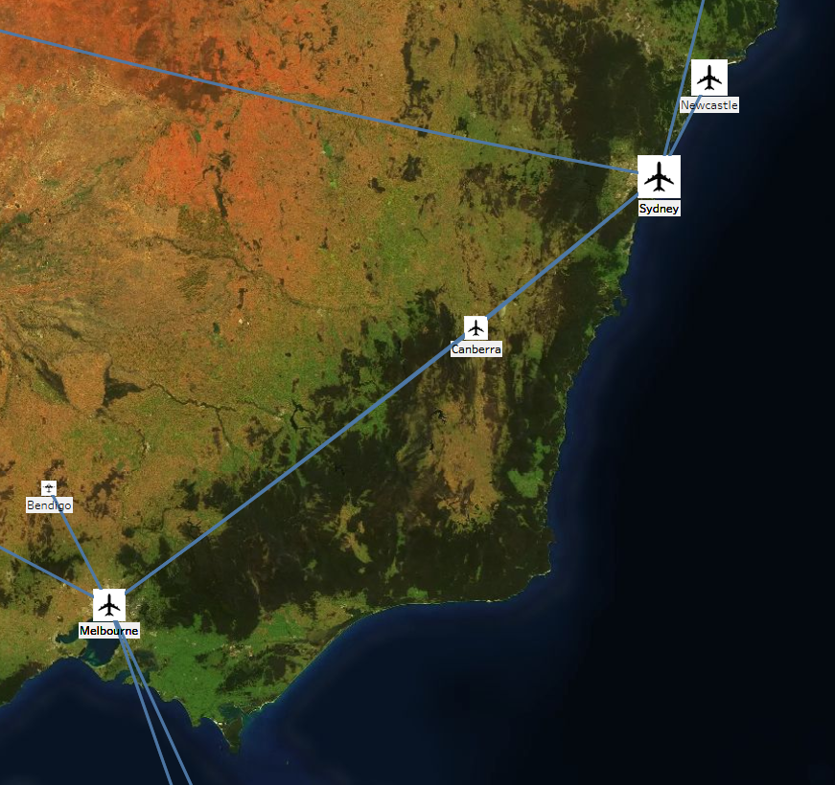

*Fig.12. Overview of Melbourne – Newcastle Route*

They can click on the Melbourne node and zoom it in and pan to Canberra node, there is one more line crossing Canberra and go to Sydney right away (Figure 13).

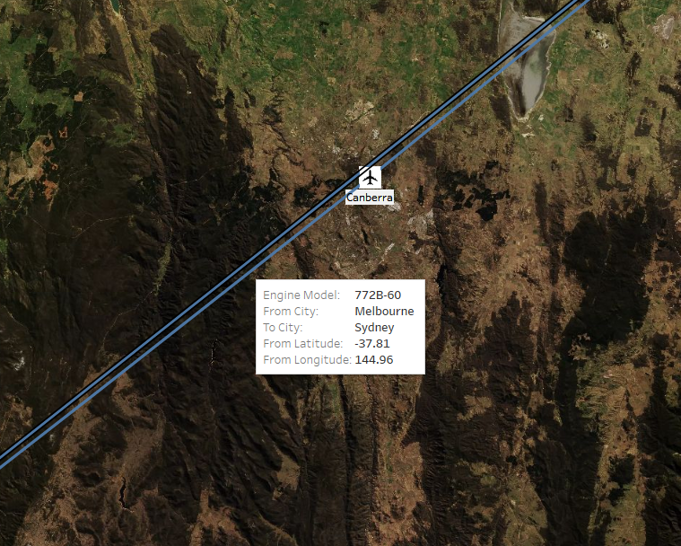

*Fig.13. Zooming in close*

Users can simply change the view of other flights. It is not only help them to deeply understand their information but also saving their time since they know exactly what they need.

When facing with the large graph data, a method called Geometric edge bundling works on the graph view generated from layout algorithms. These methods transform the large graph view with the objective to minimize the visual clutter invoked by the sheer graph size. Typical approaches in this class include edge filtering and bundling.

Cui et al. proposed a framework to bundle edges in large general graphs (Figure 14). Their method is inspired by the road map design that splits the edges in straight line into multiple segments. The control mesh is generated first according to the layout patterns. Then all the edges are forced to pass certain control points on the mesh, leading to significant reductions in visual clutter of the graph drawing.

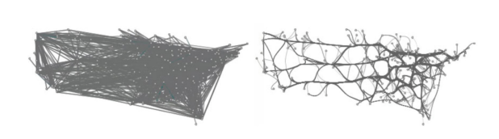

*Fig.14. Visualizations of an airline route graph by Cui et al.*

## References

* Help.tableau.com. (2020). *Mapping Concepts in Tableau*. [online] Available at: <https://help.tableau.com/current/pro/desktop/en-us/maps_build.htm> [Accessed 2 October 2020].
* Kent Marten. (2019, June 13). *Geospatial analysis made easy with two new spatial functions: MakePoint and MakeLine*. [online] Available at: <https://www.tableau.com/about/blog/2019/6/geospatial-analysis-made-easy-two-new-spatial-functions-makepoint-and-makeline> [Accessed 6 October 2020].
* W. Cui, H. Zhou, H. Qu, P. C. Wong, and X. Li. Geometry-based edge clustering for graph visualization. IEEE Transactions on Visualization and Computer Graphics, 14:1277–1284, 2008.